Name Date
Progress test 3
Listening
Part 1
There are five questions in this part.
For each question there are three pictures and a short recording.
For each question tick the best answer, A, B or C.

1 Who went on holiday?
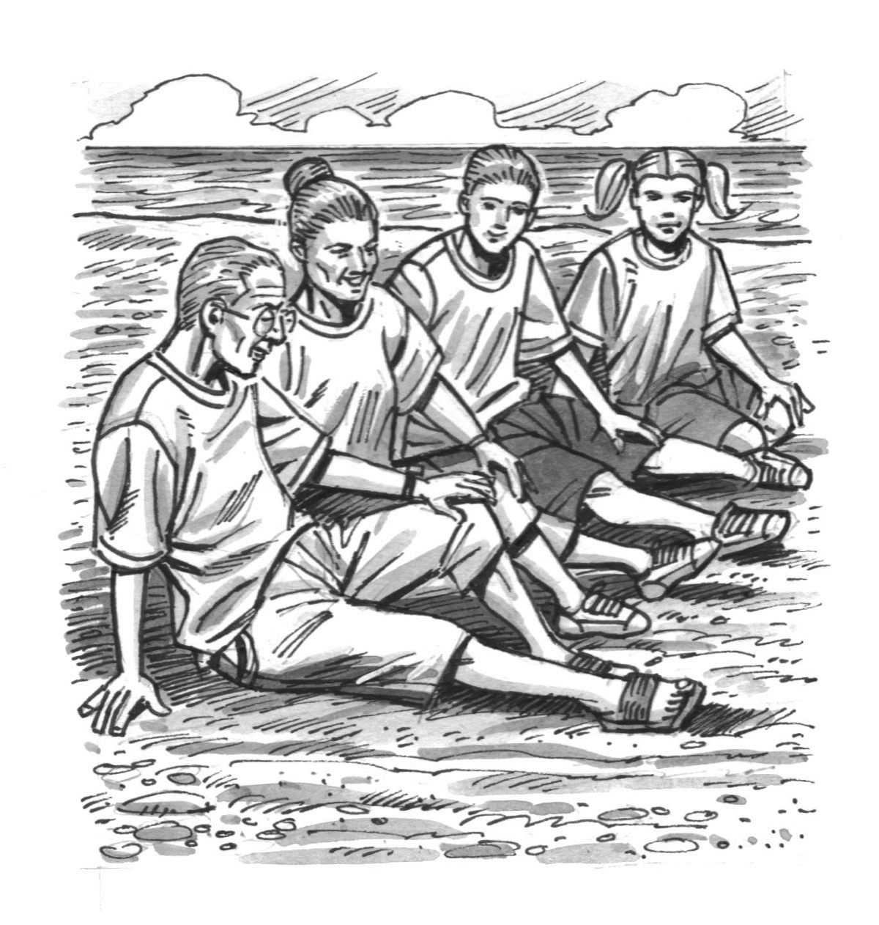
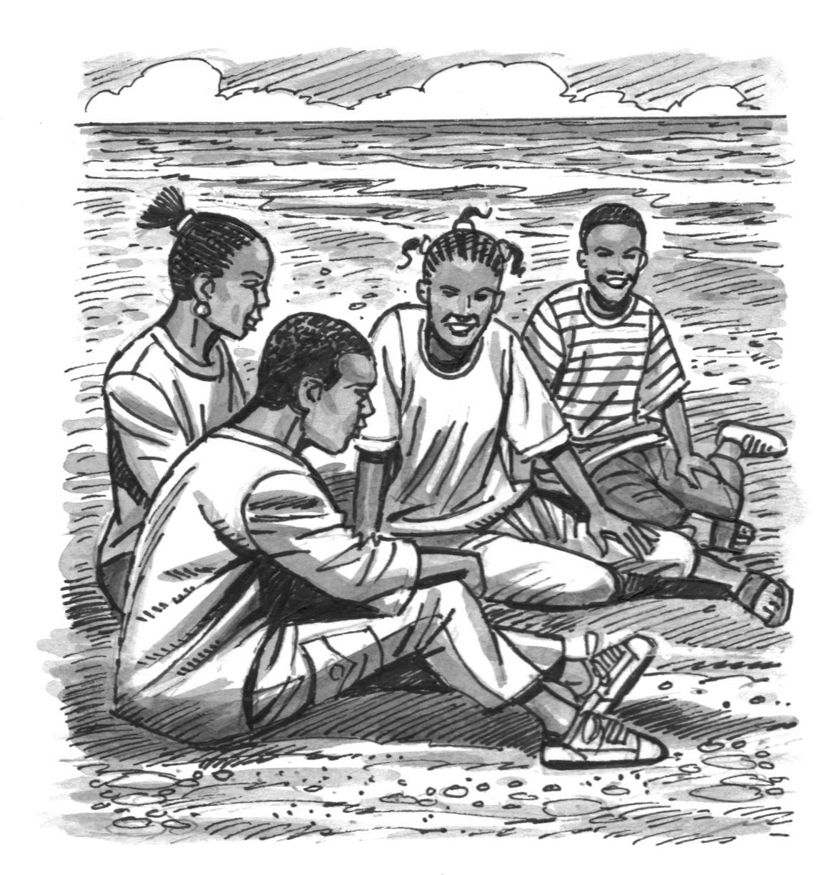
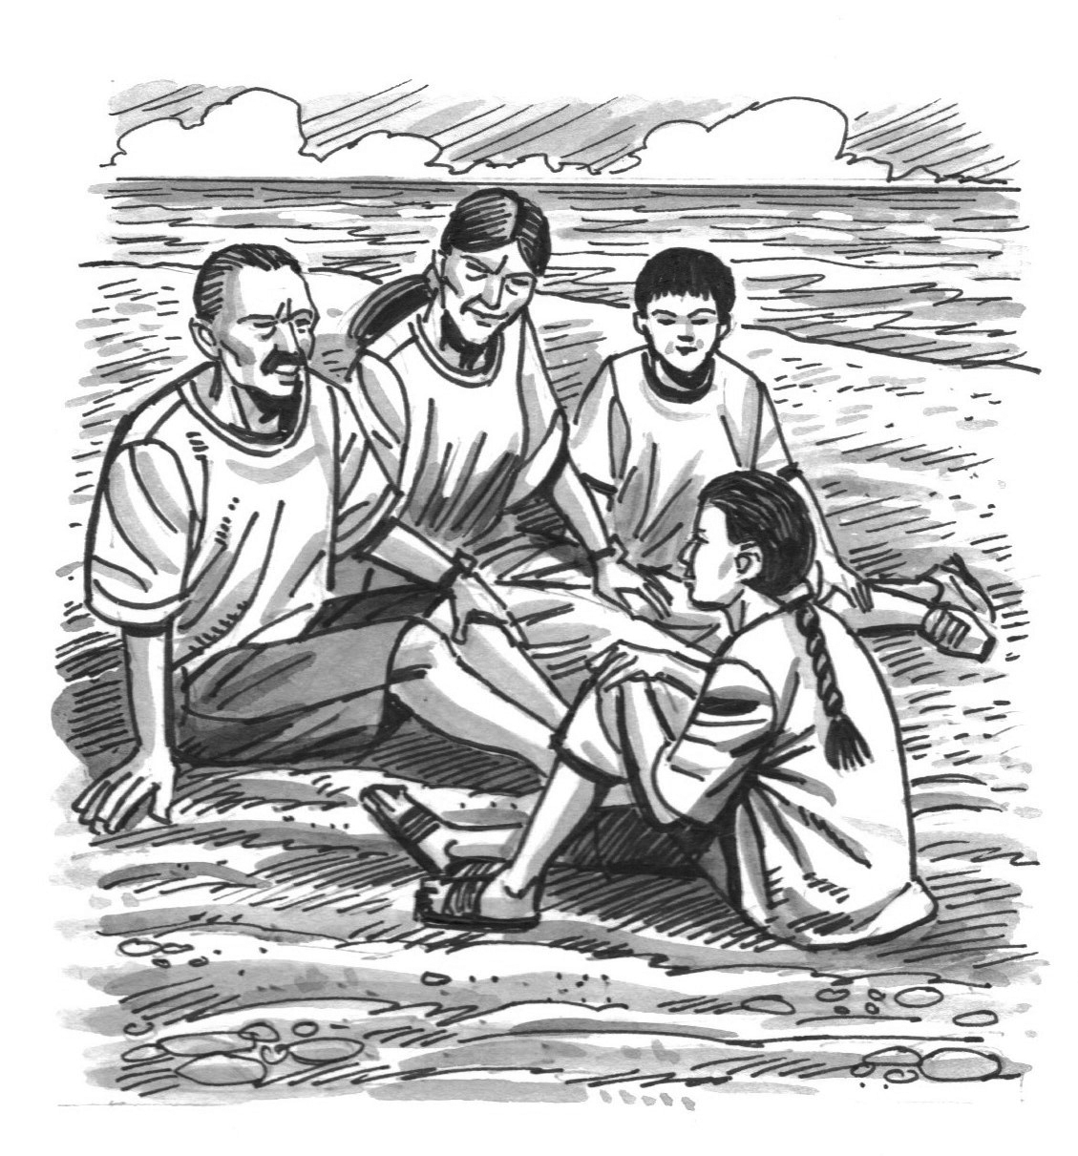

A B C
2 What did the girl do in the evening on her birthday?
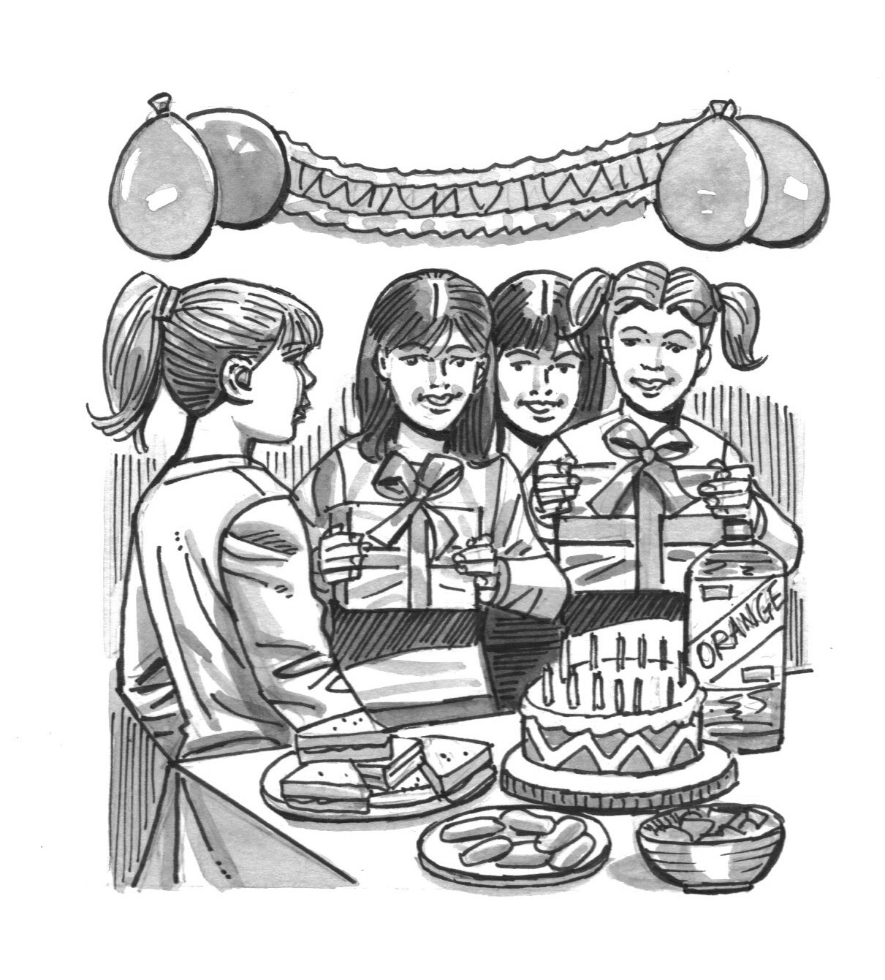
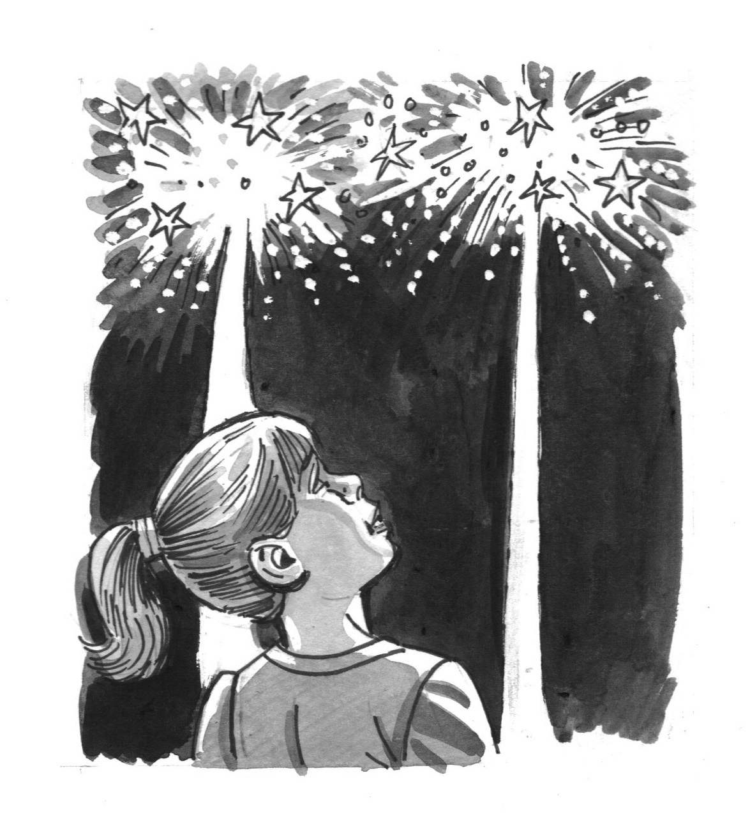
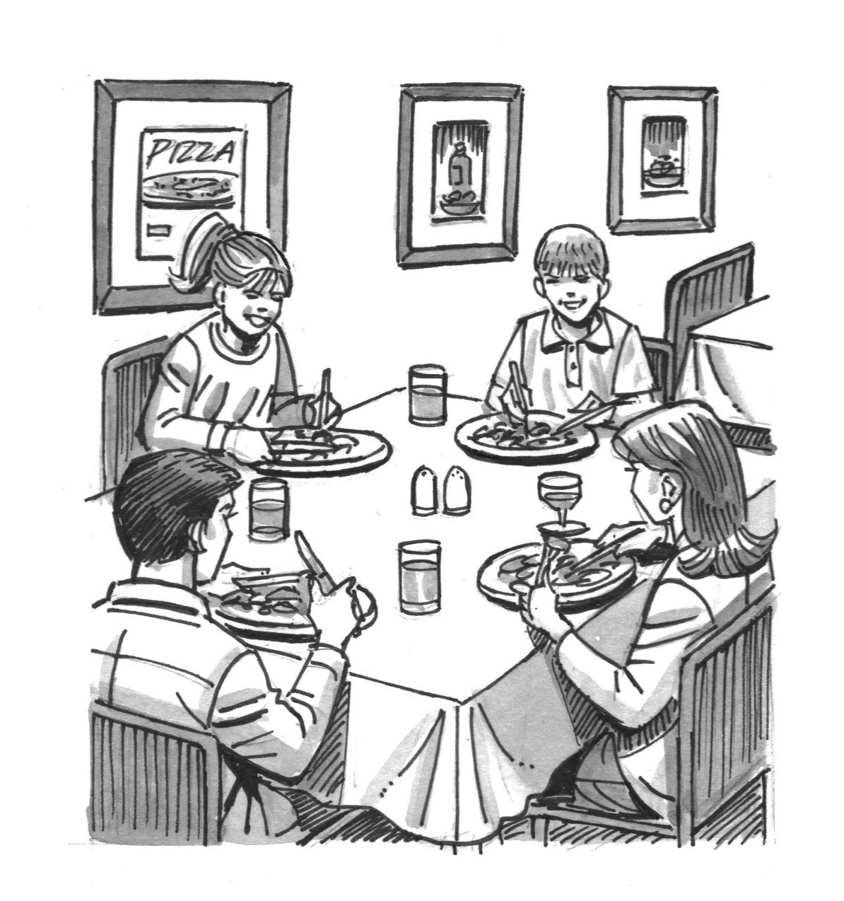

A B C



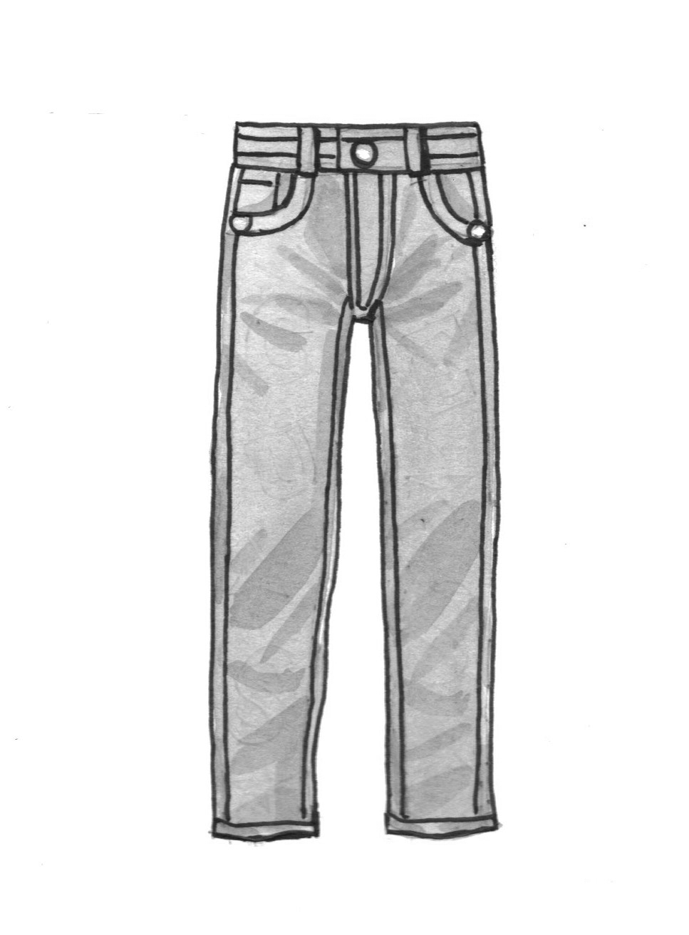
3 What did the boy borrow from his brother?

A B C
4 Which city did the girl visit at the weekend?
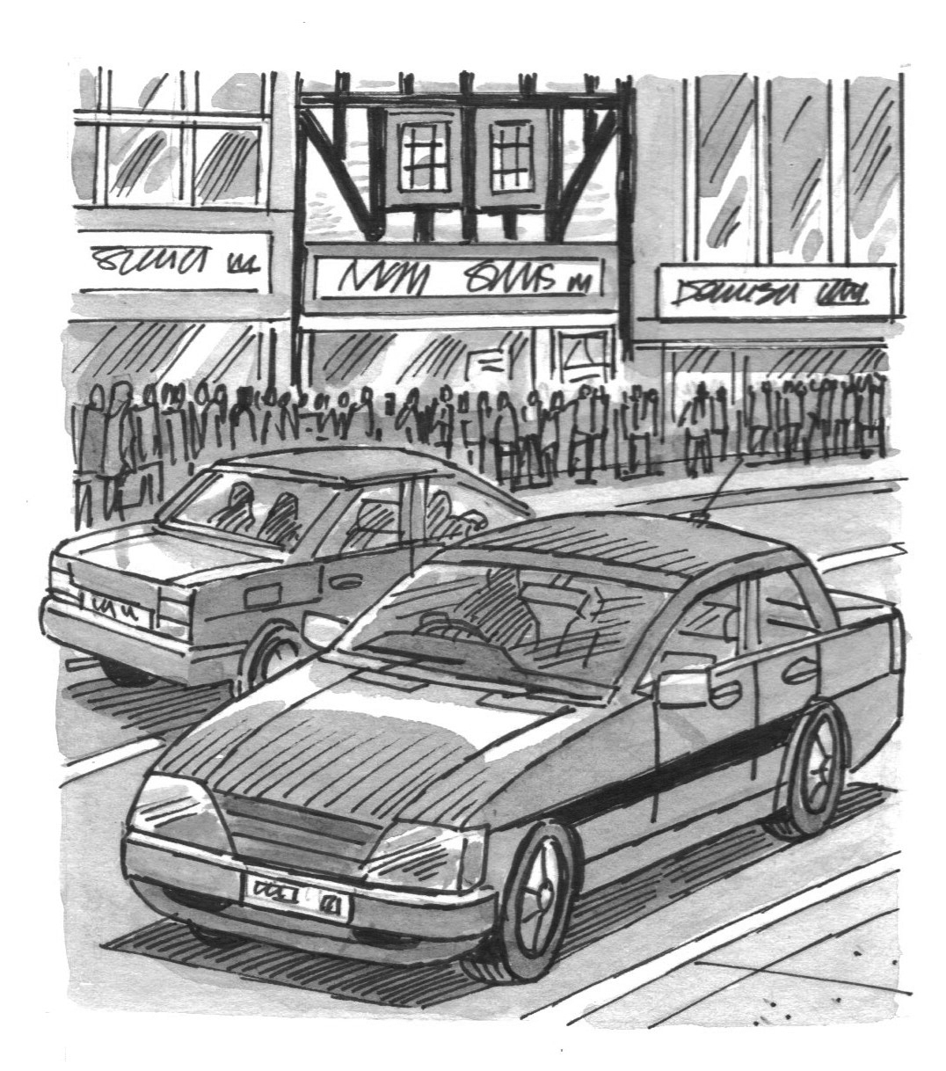
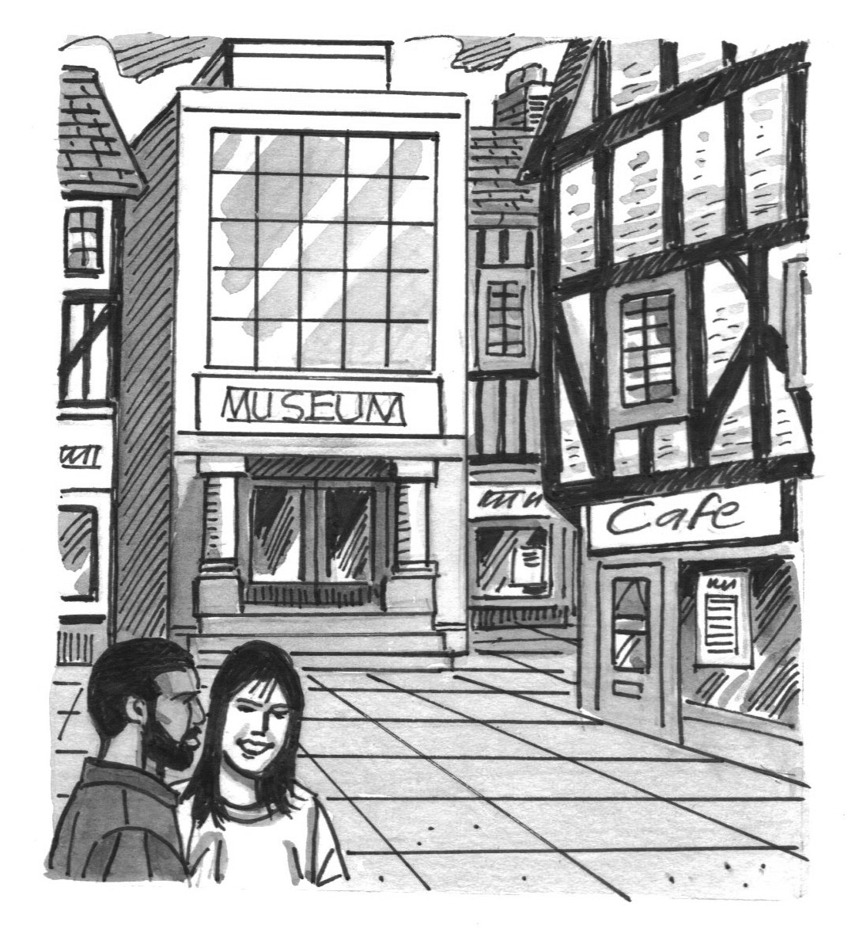
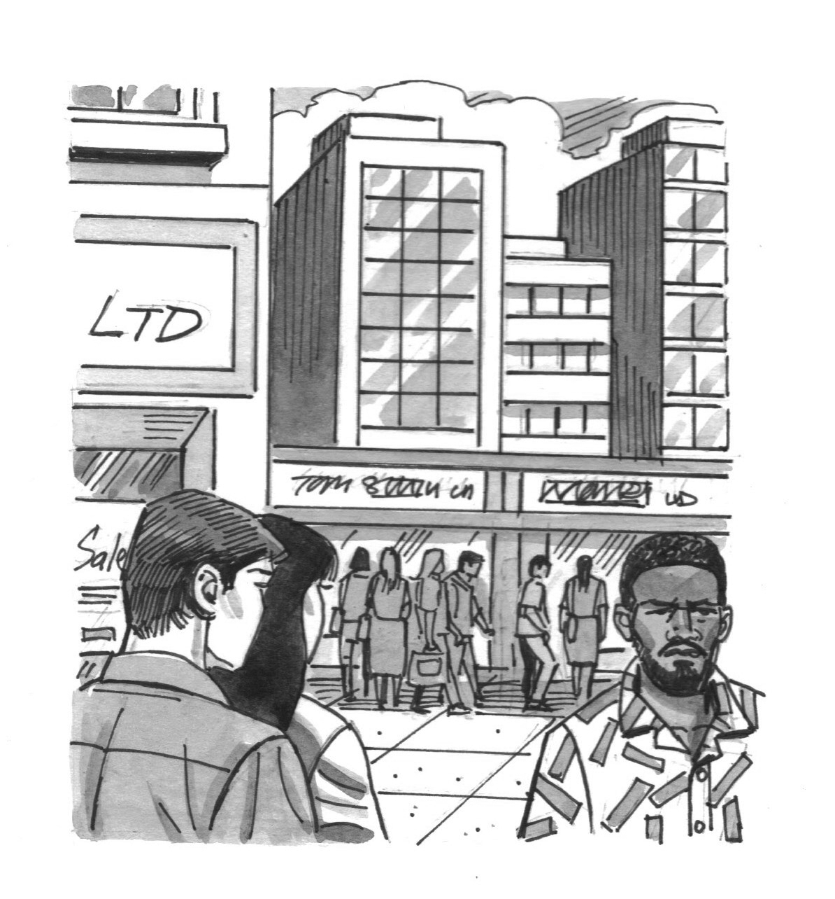

A B C
5 Which activity did the boy enjoy most?
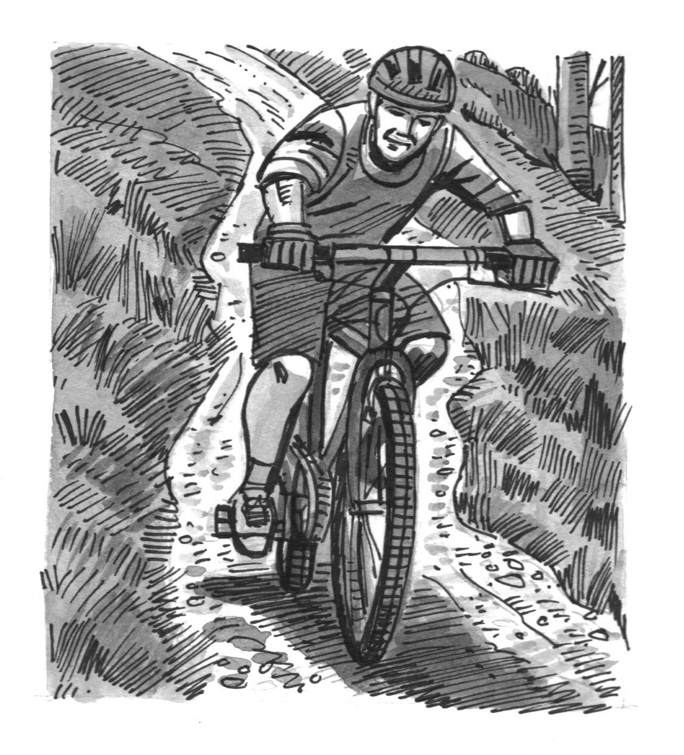
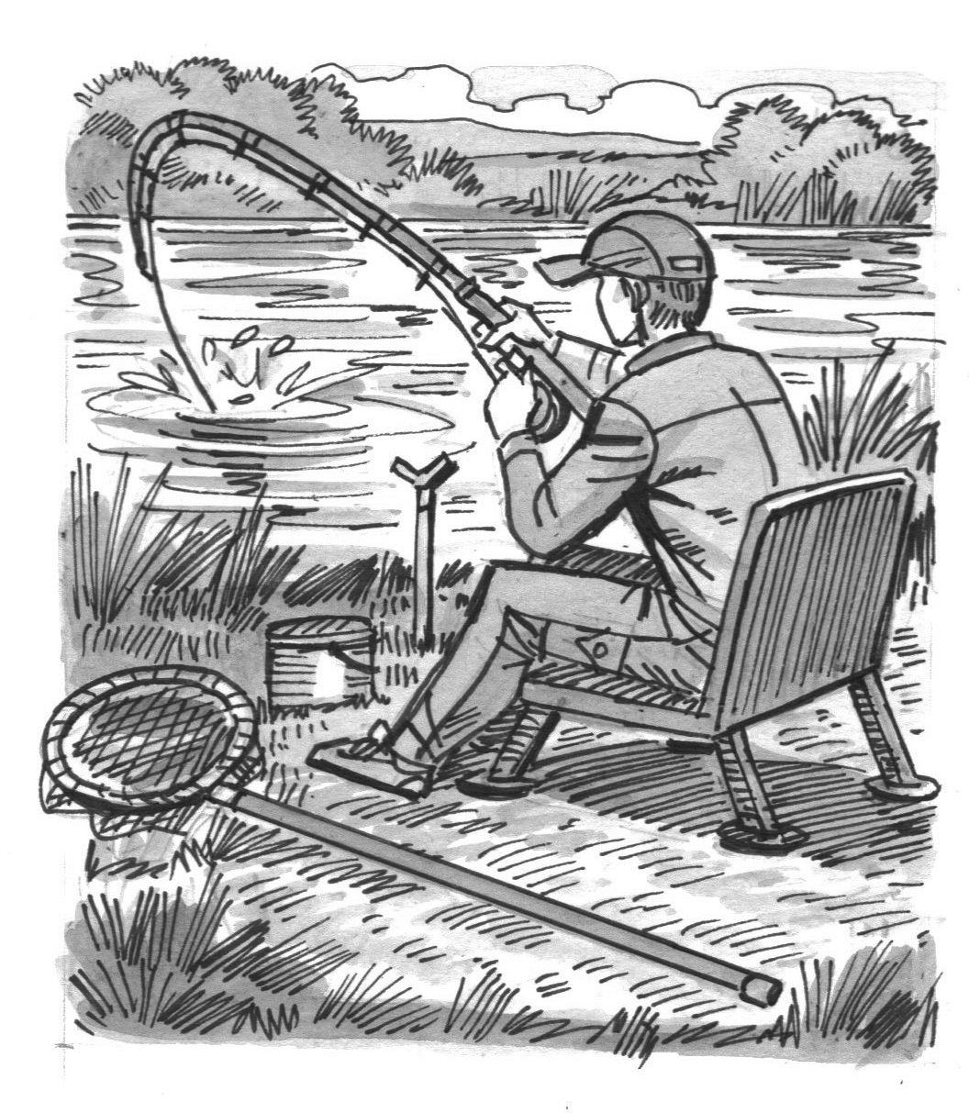
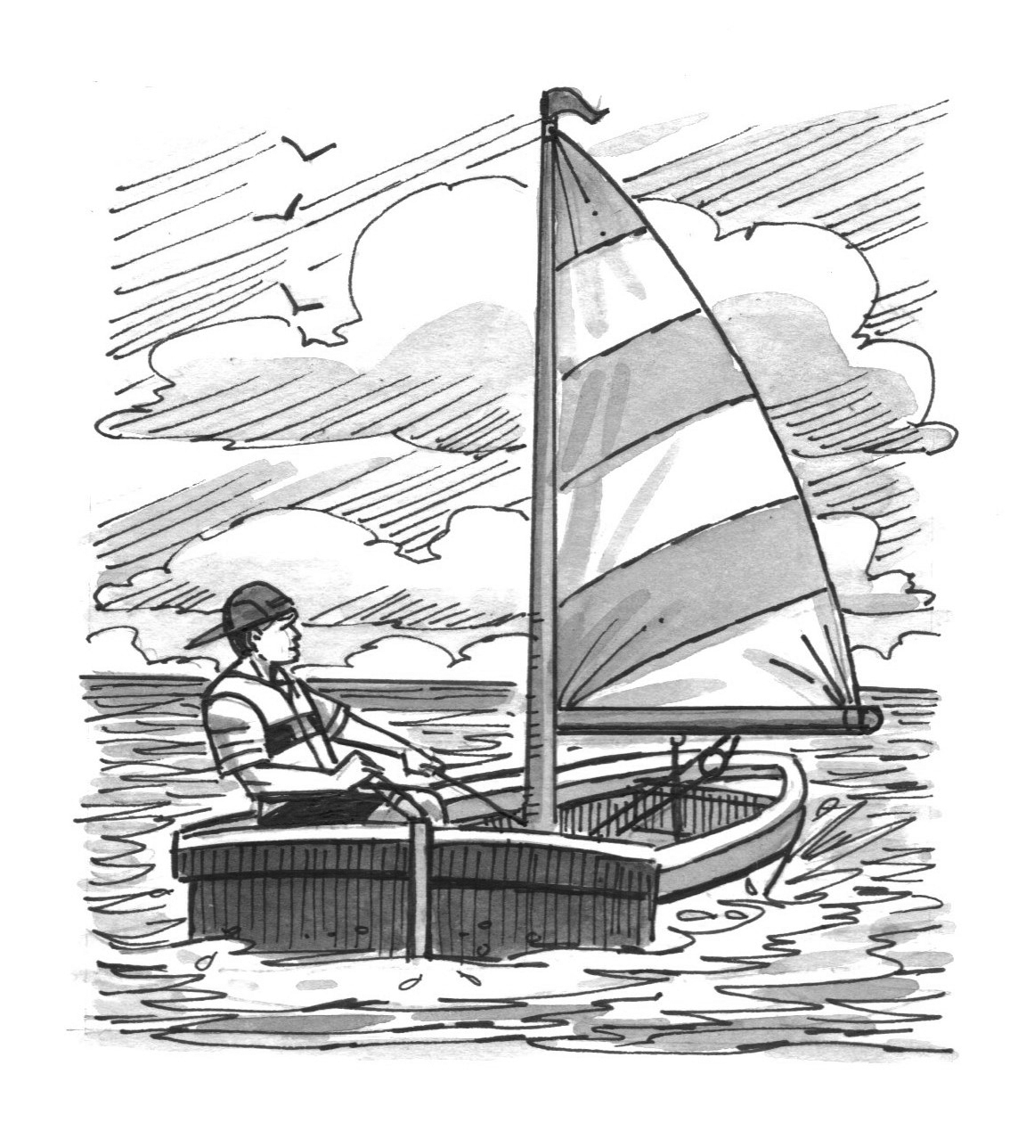

A B C
[Total: 5 marks]

Part 2
You will hear people talking in five different situations.
Circle the best answer, A, B or C.

6 You hear a boy talking about a football match he went to.
What surprised him about it?
A the score at the end
B the size of the crowd
C the determination of the players

7 You hear two classmates talking about becoming a vet in the future.
Why doesn’t the girl want to become a vet?
A She’d have to work too many hours.
B It involves too much studying.
C The work would be too difficult.

8 You hear two friends talking about using social media.
What do they agree about?
A They spend too much time on it.
B It’s a great way to contact friends.
C They don’t accept many friend requests.

9 You hear two friends talking about apps for their phones.
What has the boy just downloaded?
A a sport app
B a weather app
C a music app

10 You hear two friends talking about a concert they went to.
How does the girl feel about the concert?
A enthusiastic about seeing the band again
B surprised by the band’s choice of songs
C disappointed by how long the band played for

[Total: 5 marks]

Part 3
You will hear a student called Melanie giving a talk to a class about working on the school’s student
news website.
Complete the sentences with a word or short phrase.

Student news website

Melanie works as a (11) on the student news website team.
………….………….………
The team that works on the website meets on (12) every week after school.
………….………….………
Melanie says the team only asks teachers for help if they have a problem with the
(13) .
………….………….………
Melanie says that the (14) page is the most popular section of the website.
………….………….………
Email (15) @schoolnews.net for more information about joining the school student website team.
………….………….………
[Total: 5 marks]

Part 4
You will hear an interview with a young man called Harry Miller, who is a singer.
Circle the best answer, A, B or C.

16 Harry started singing after
A going to a concert.
B hearing a relative.
C watching an online video.

17 Where did Harry do his first show?
A in a café
B in the street
C at school

18 How often does Harry practise now?
A every day
B every two days
C every week

19 What does Harry say about the musicians he works with?
A They get on with each other really well.
B They’re the best in the world.
C He’s known them for a long time.

20 Harry says that if he wasn’t a singer, he would
A work with numbers.
B become a teacher.
C go to university.
[Total: 5 marks]

Part 5
You will hear five teenagers talking about writing a blog.
Choose from the list A–H what each speaker says about writing a blog.
Write the correct letter in the box next to each speaker.
There are three extra letters that you do not need to use.

A I started writing it recently.
B I get upset by negative comments. 21 Speaker 1
C I write about a range of topics. 22 Speaker 2
D My first few posts were badly written. 23 Speaker 3
E I might give up writing it soon. 24 Speaker 4
F More people read my posts than I expected. 25 Speaker 5
G I write it with someone else’s help.
H I upload posts more often than before.

[Total: 5 marks]

Reading and Use of English
Part 1
For each question, choose the correct answer, A, B or C.
Example:
0 My name’s Danielle, and I love snowboarding – it’s my (0)…………. sport.
A nicest B most C favourite

Why I do snowboarding

You need lots of skills to be able to snowboard, including strength, (1) and agility. I live in the UK, which isn’t very cold and doesn’t (2) much snow. Fortunately, there’s an (3) skiing and snowboarding centre near where I live so I can (4) snowboarding even when there isn’t any snow outside.
………….…
………….…
………….…
………….…
I started (5) snowboarding competitions there a few months ago. I haven’t (6) won
any yet, but I came second in one last weekend, so I’m definitely (7) In the future, I want to
(8) part in big international events like the Winter Olympics.
………….…
………….…
………….…
………….…

1 A courage B courageous C encourage
2 A make B keep C get
3 A inside B indoor C into
4 A practise B prepare C exercise
5 A playing B entering C arriving
6 A anyway B already C actually
7 A completing B growing C improving
8 A take B have C do
[Total: 8 marks]

Part 2
Look at the text in each question. What does it say?
Circle the correct letter, A, B or C.
Example:

A Lily’s dad wants Lily to make an appointment at the dentists later today.
Lily,
I haven’t forgotten that you’ve got an appointment after school today. If you go straight to the dentists, I’ll see you there and give you
a lift home.
Dad

0
B Lily’s dad will pick Lily up from school and take her to the dentists.
C Lily’s dad will meet Lily at the dentists and take her back to their house.

Why did Juan send this message?
9
From: Juan
To: Andrew

As you know, it’s my party next weekend. I was wondering if you’d be able to organise the music. You’ve got so many great songs on your laptop!
A to ask Andrew for a favour
B to invite Andrew to a party
C to remind Andrew about an agreement

A Some of the animals in the National Park are dangerous.
The animals in the
National Park are all wild
and should never be fed.

10
B It’s very difficult to see wild animals in the
National Park.
C Visitors should not give wild animals any of their food.

A Ingrid wants to go diving again on holiday next year.
Dear Grandad,

The holiday’s great! We’ve swum in the sea every day. I want to try diving, but dad thinks I’m too young. Maybe he’ll let me do it next year.

Ingrid
11
B Ingrid would like to have a go at doing something new.
C Ingrid learned how to dive quite a long time ago.


A Anna will let Diana know if their arrangement for the weekend can’t happen.
12
Diana,

Going shopping on Sunday should be fine. I haven’t asked my mum yet, but she goes into town every weekend. I’ll text if there’s a change of plan.
Anna
B Anna’s mum has changed her plans and won’t go into town this weekend.
C Anna wants Diana to persuade Anna’s mum to let them go shopping with her.


A It costs $5 to travel to the Science Museum and $5 to go in.
Science museum trip

Inform the school secretary by
24 February if you’d like to go on the museum trip on 3 March. $5 per student, including transport and entrance fee.

13
B Students need to make a decision about going to the museum by 24 February.
C The trip to the museum has been moved from
24 February to 3 March.

[Total: 5 marks]

Part 3
Complete the conversation between two friends.
What does Omar say to Yousef?
Write the correct letter, A–H, from the answers on the next page.
Example:
Yousef: Hi Omar. Are you free this evening?
………….
Omar: 0 H

Yousef: Nothing exciting! We need to begin writing our homework project.
Omar: 14 ………….

Yousef: We do, and we haven’t even started it yet. It’s about transport, isn’t it?
Omar: 15 ………….

Yousef: I’ve already got lots of information about them.
Omar: 16 ………….

Yousef: Great! So do you want to come and work on it at my house?
Omar: 17 ………….

Yousef: That’s true! OK, is 6.30 OK for you?
Omar: 18 ………….

Yousef: No problem! Let’s say 7 o’clock then. See you then.
[Total: 5 marks]

A Me too. My dad’s got two good books we can use.
B That time’s fine with me.
C Oh, yes. We need to finish it before Friday.
D It’s probably quieter there. My brother’s really noisy!
E We need to decide which type to choose.
F Yes, and we decided to write about trains.
G Could I come a bit later? I usually have dinner quite late.
H Why? What are you thinking of doing?

Part 4
For each question, write the correct answer.
Write one word for each gap.

From: Amir
To: Cameron
Hi Cameron,
Remember me telling you (0) about a new film club at school? Well, I (19) …………….
talking to my English teacher today, and she said that it’s starting next week. You love films, so
(20) ……………. don’t you join too? I’ve just checked on the school website and (21) …………….
are lots of details on there, saying when the meetings are and (22) ……………. often the club meets,
and so on.
………….……
The first film they’re showing at the film club is (23) ……………. of my favourites. It’s an action
movie called The Long Run. (24) …………….. you ever seen it? It’s very exciting and I think it’s
(25) ……………. kind of film you really like.
What (26) ……………. you think? Would you like to join?
Amir
[Total: 8 marks]

Part 5
You are going to read an article about a girl’s first job.
Choose from the sections A–D to answer the questions on the next page. The sections may be
chosen more than once.

My first job
16-year-old Antonella Smith talks about her weekend job.
A
I’ve worked in a café near my home for about four months now. My hobby is horse-riding, which
really isn’t cheap. I didn’t think it was fair to ask my parents to pay, so I do a few hours at the café
every weekend, which allows me to cover the cost. I can’t actually believe how enjoyable it’s been
so far. When I’ve visited cafés as a customer, I’ve often thought how dull the jobs there seemed, but
I was wrong. Because I do lots of different things there, from preparing food and cooking to taking
orders and serving customers, I never feel bored.
B
I’ve always enjoyed cooking, so it was no surprise that I’d like that part of the work, and I can now
make lots of dishes that I’d never even heard of before. There’s nothing I like more than chatting to people who come into the café. Quite a famous author came in for lunch with her husband last week.
She writes really good novels for teenagers and I’d actually read one of her books. I asked her how
she’d thought of the story for it and whether there’d be another book in the future with the same characters. Her replies were all really interesting.
C
The café’s owned by a really nice couple, who are more like my friends than my bosses. It’s a real pleasure to work for them. They’re originally from Poland but have lived in the town for about seven years. Some of the things we prepare are actually based on Polish dishes. They’re all very tasty, and customers seem to love them. In fact, they’re probably the most popular items on the menu. There are
20 tables in the café altogether, so there can be over 50 customers when it’s full – it can get
really busy.
D
A couple of other part-time staff also have weekend jobs there, which is when the café’s at its busiest.
So there are usually five of us doing all the various jobs that need doing then. The café’s open during the week too, and I sometimes go there with my friends after school, but as a customer of course, not to work. I work there for seven hours every Saturday, which still gives me plenty of time to do all of the other things I’m interested in. Who knows? Maybe I’ll end up serving you one day!

In which section does the writer:
27 describe what she talked to a customer about? ……….……
28 say that she occasionally visits the café in her free time? ……….……
29 show surprise at how much she likes the work? ……….……
30 describe some of the food that is served at the café? ……….……
31 say what she’s learned to do by working at the café? ……….……
32 explain the reason for getting her job? ……….……
33 say how many people work at the café? ……….……
34 say what she enjoys most about her job? ……….……
35 describes her relationship with the people she works with? ……….……
36 explain why her roles at the café suit her? ……….……
[Total: 10 marks]

Part 6
You are going to read an article about a girl who enjoys writing poetry.
Read the questions on the next page.
For each question, choose the correct answer, A, B, C or D.

Writing poetry
By 15-year-old Heather Armstrong
I first got into reading poetry in my free time when I was 12 years old. It was after we studied a
poem called ‘The Shout’ at school. My English teacher saw how much I liked it and gave me a
special copy of the poem. It was after my mum and dad showed me a book of poetry that my
maternal grandmother wrote 50 years ago that I decided I’d like to have a go at creating my
own poems.
I didn’t really know how to do it, so I decided to join a weekend poetry class for teenagers at the
local college. In our first class, the teacher wouldn’t let us write anything at all. We spent the whole lesson listening to him telling us how important poetry was. He was quite a well-known poet, so it
wasn’t that I thought what he was saying was wrong, it just seemed like a complete waste of time.
As the course continued, I realised why he’d done it and what a great teacher he was. I was soon
writing poems that I was really proud of, and he suggested trying to get them published. I sent one
to a poetry website, which put it on their site a few weeks later, and another to our local newspaper,
which printed it the following week. I wouldn’t feel comfortable having one of my poems in the
school magazine though. I’m hoping that one will appear in a book of poetry by teenagers one day.
Although my poems are quite short, I’m not that fast at writing them. It's sometimes hard to get ideas,
and I can spend weeks thinking about them before I write anything. I find that walking in beautiful landscapes or watching wild animals gives me far more ideas than thinking about my own life, so I’ve used this to create almost all of my poems. And I try to avoid being too old-fashioned and copying poets from the past. I love my hobby!

37 Why did Heather decide to start writing poetry?
A A school teacher persuaded her.
B She read a relative’s work.
C She received a poem as a gift.
D Her parents suggested it.

38 What did Heather think of her poetry teacher at first?
A He wasn’t very good at writing poems.
B He talked too much.
C He didn’t explain things well.
D He was too strict.

39 The first of Heather’s poems to be published appeared
A in the school magazine.
B on a poetry website.
C in a local newspaper.
D in a book of teenage poetry.

40 Heather says that most of her poetry
A is inspired by nature.
B is about her own life.
C is written quite quickly.
D is quite traditional.

41 What would Heather write in her diary?
A I’m so glad I’ve got a new poetry teacher now. The old one was absolutely terrible!
B I never knew my dad’s side of the family wrote poetry. I’ll have to ask Dad if he’s written any.
C I’ve been thinking about butterflies for weeks. Finally I’ve started writing a poem about them.
D I’d already written lots of poems, so I felt I was ahead of the other students in my poetry class.

42 What is Heather doing in this text?
A explaining why more teenagers are writing poetry these days
B suggesting which styles of poetry young people should write
C encouraging other teenagers to start writing poetry
D describing her experiences of learning to write poetry.
[Total: 6 marks]

